Liquids and Solids
Changes of State
B. Heating Curves

Heat Capacity

____________ required to raise the temp of 1 gram of a substance by 1°C

Temperature Change
change in ____________________
depends on ________________

Heat of Fusion (ΔHfus)

energy required to melt 1 gram of a substance at its m.p.

Phase Change
change in ______________________
__________ remains constant
Heat of Vaporization (ΔH_{vap})
energy required to boil 1 gram of a substance at its b.p.
usually larger than ΔH_{fus}…why?

C. Phase Diagrams
Show the ___________________ of a substance at different _______________________.

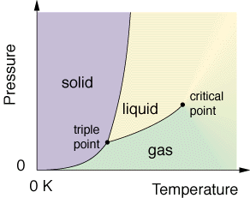

What condition is necessary for water to sublime?

D. q = mcΔT Problems

Sample
How much heat energy is needed to raise a 55 g sample of aluminum from 22.4˚C to 94.6˚C ?

